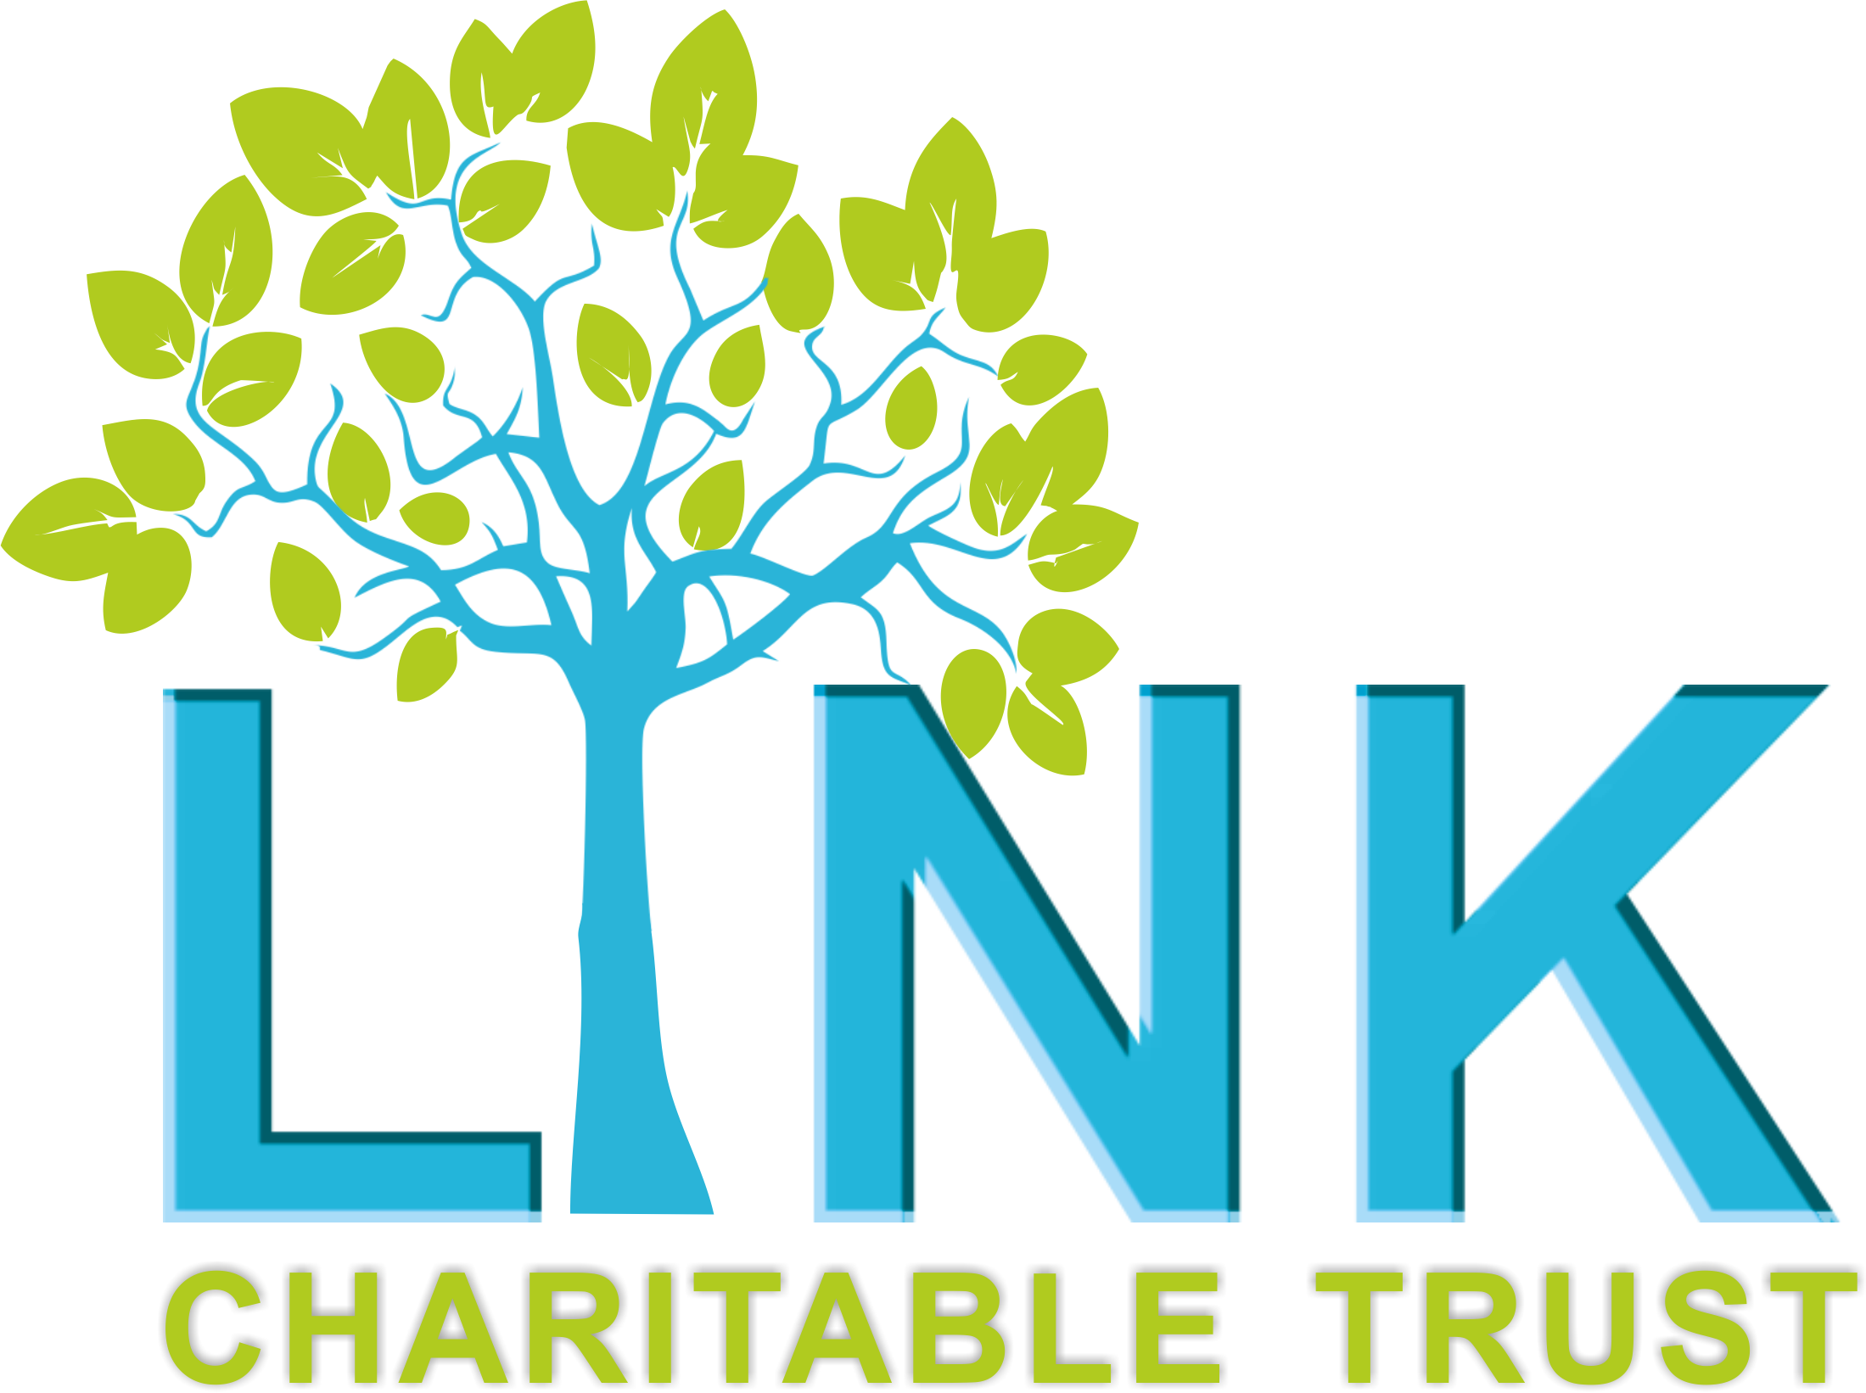
THE LINK CHARITABLE TRUST
JOB ADVERTISEMENT

Adult Mental Health Service Manager

The Link Charitable Trust (LCT) is a Redcar based charity working with children, young people, families and vulnerable adults. We support individuals to make positive changes to their lives through a range of emotional, social and wellbeing activities and services within the community.

We are currently recruiting a Service Manager to oversee the Adult Mental Health Services at The Link Charitable Trust. This post is fixed term until June 2027, 22.5 hours per week, £32,136 FTE (£21,425 pro rata) Working hours and patterns are negotiable.

The desirable candidate will have a passion for working to improve the Mental Health and Emotional wellbeing of adults in the Redcar and Cleveland area, supporting the development of key partnerships and initiatives across the area. The successful post holder will have previous management experience, knowledge of mental health difficulties, and an understanding of the voluntary sector.

The post holder will also have an active role in supporting the community, carrying out assessments and supporting the facilitation of group activities.

Application Deadline: Thursday 11th December
Interviews: Tuesday 16th December

To apply for this post, please complete an application form and send it to: callum@linkct.org.uk

Application packs can be found on our website (www.linkct.org.uk), or you can contact us by email: office@linkct.org.uk or 01642 989198.

For further information, or to discuss this post please contact Katie Finkill on 01642 989198.

