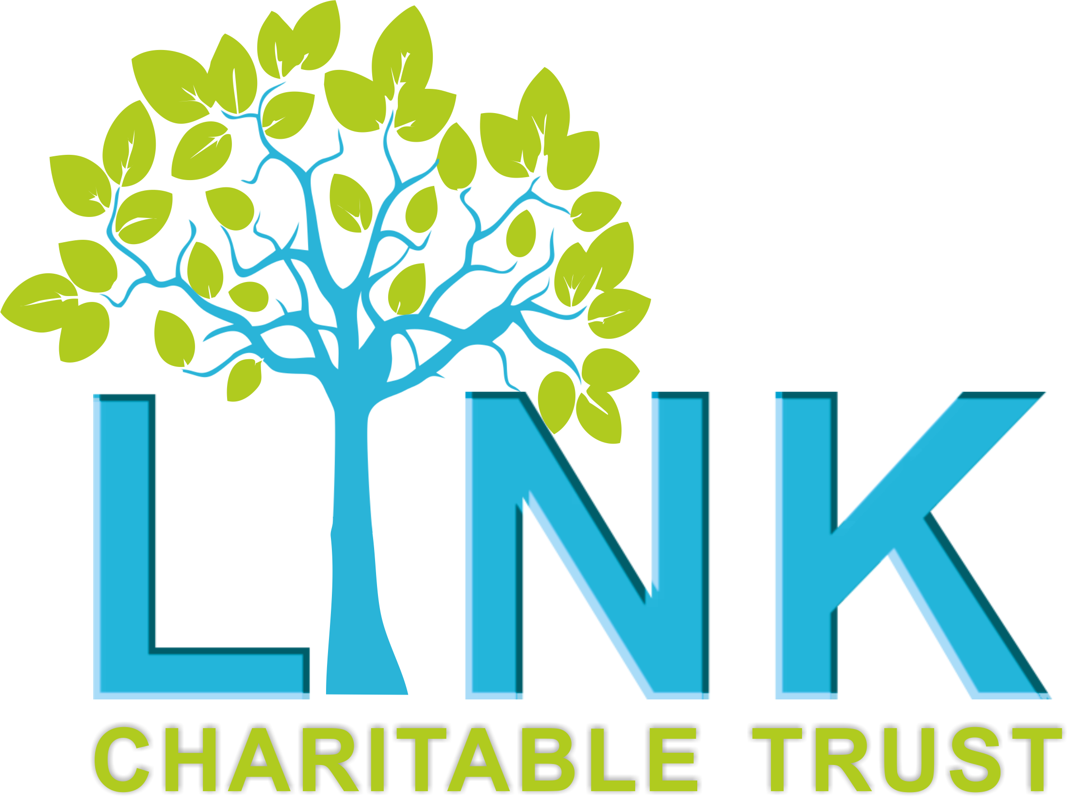

**Charity Manager**

**Person Specification**

This outlines the key criteria for the post. Shortlisting will be based on the ability to meet these criteria. Please ensure your supporting statement clearly shows how you meet each one, using examples from your skills, knowledge and experience.

**We welcome your application**

We are an equal opportunities employer and are committed to building an inclusive workplace. If you’re excited by the opportunity but unsure if you meet every requirement – we’d still love to hear from you.

|  |  |  |
| --- | --- | --- |
| **Criteria** | **E - Essential**  **D - Desirable** | **Measured By**  **A - Application**  **I - Interview** |
| **Qualifications**   * Graduate, ideally with a relevant postgraduate qualification (e.g. community development, leadership, mental health, management) | E | A |
| * Evidence of continuous personal and professional development | E | A |
| * Holds a business or charity management qualification | D | A |
| **Experience**   * Minimum of 3 years’ experience working in a senior leadership role | E | A/I |
| * Strong understanding of The Link Charitable Trust’s work, values and community impact | E | A/I |
| * Experience in mental health or emotional wellbeing services (children, young people and/or adults | E | A/I |
| * Proven experience of managing safeguarding policies and procedures | E | A/I |
| * Substantial experience of working within the voluntary/charitable sector | E | A/I |
| * Demonstrable success in securing income from grants, contracts or fundraising initiatives | E | A/I |
| * Experience of representing an organisation at a senior level with key stakeholders, funders and beneficiaries in order to build confidence and reputation | E | A/I |
| * Experience working collaboratively with boards/trustees and contributing to effective governance | D | A/I |
| * Experience delivering multi-year organisational strategies and demonstrating measurable impact | D | A/I |
| * Knowledge of financial planning, budgeting and HR practices | E | A/I |
| * Experience overseeing cross-functional operations (e.g. finance, HR, IT, marketing, communications) | D | A/I |
| **Knowledge, skills and abilities**   * Demonstrable understanding of good governance, risk management and organisational compliance. | E | A/I |
| * Strong relationship-building skills with partners, funders, local authorities and VCSE networks | E | A/I |
| * Confident ambassador and spokesperson, with public speaking/media experience | E | A/I |
| * Excellent decision-making, critical thinking and problem-solving abilities | E | A/I |
| * Ability to lead and motivate teams, providing vision and strategic direction | E | A/I |
| * Understanding of and ability to lead on Health & Safety and risk assessments | D | A/I |
| * Competent in the use of IT, particularly Google Suite and CRM/databases | D | A |
| **Personal qualities and other attributes**   * Exceptional written and verbal communicator, with strong presentation skills | E | A/I |
| * Demonstration of self-motivation and motivation of others | E | A/I |
| * Able to work under pressure, balance priorities and meet deadlines | E | A/I |
| * Commitment to the core values, aims, and policies of The Link Charitable Trust | E | A/I |
| * Passionate about improving mental health and emotional wellbeing outcomes | E | I |
| * Empathetic and non-judgemental approach to supporting others | E | I |
| * Able and willing to work occasional unsocial hours and outside of normal office hours as required | D | I |