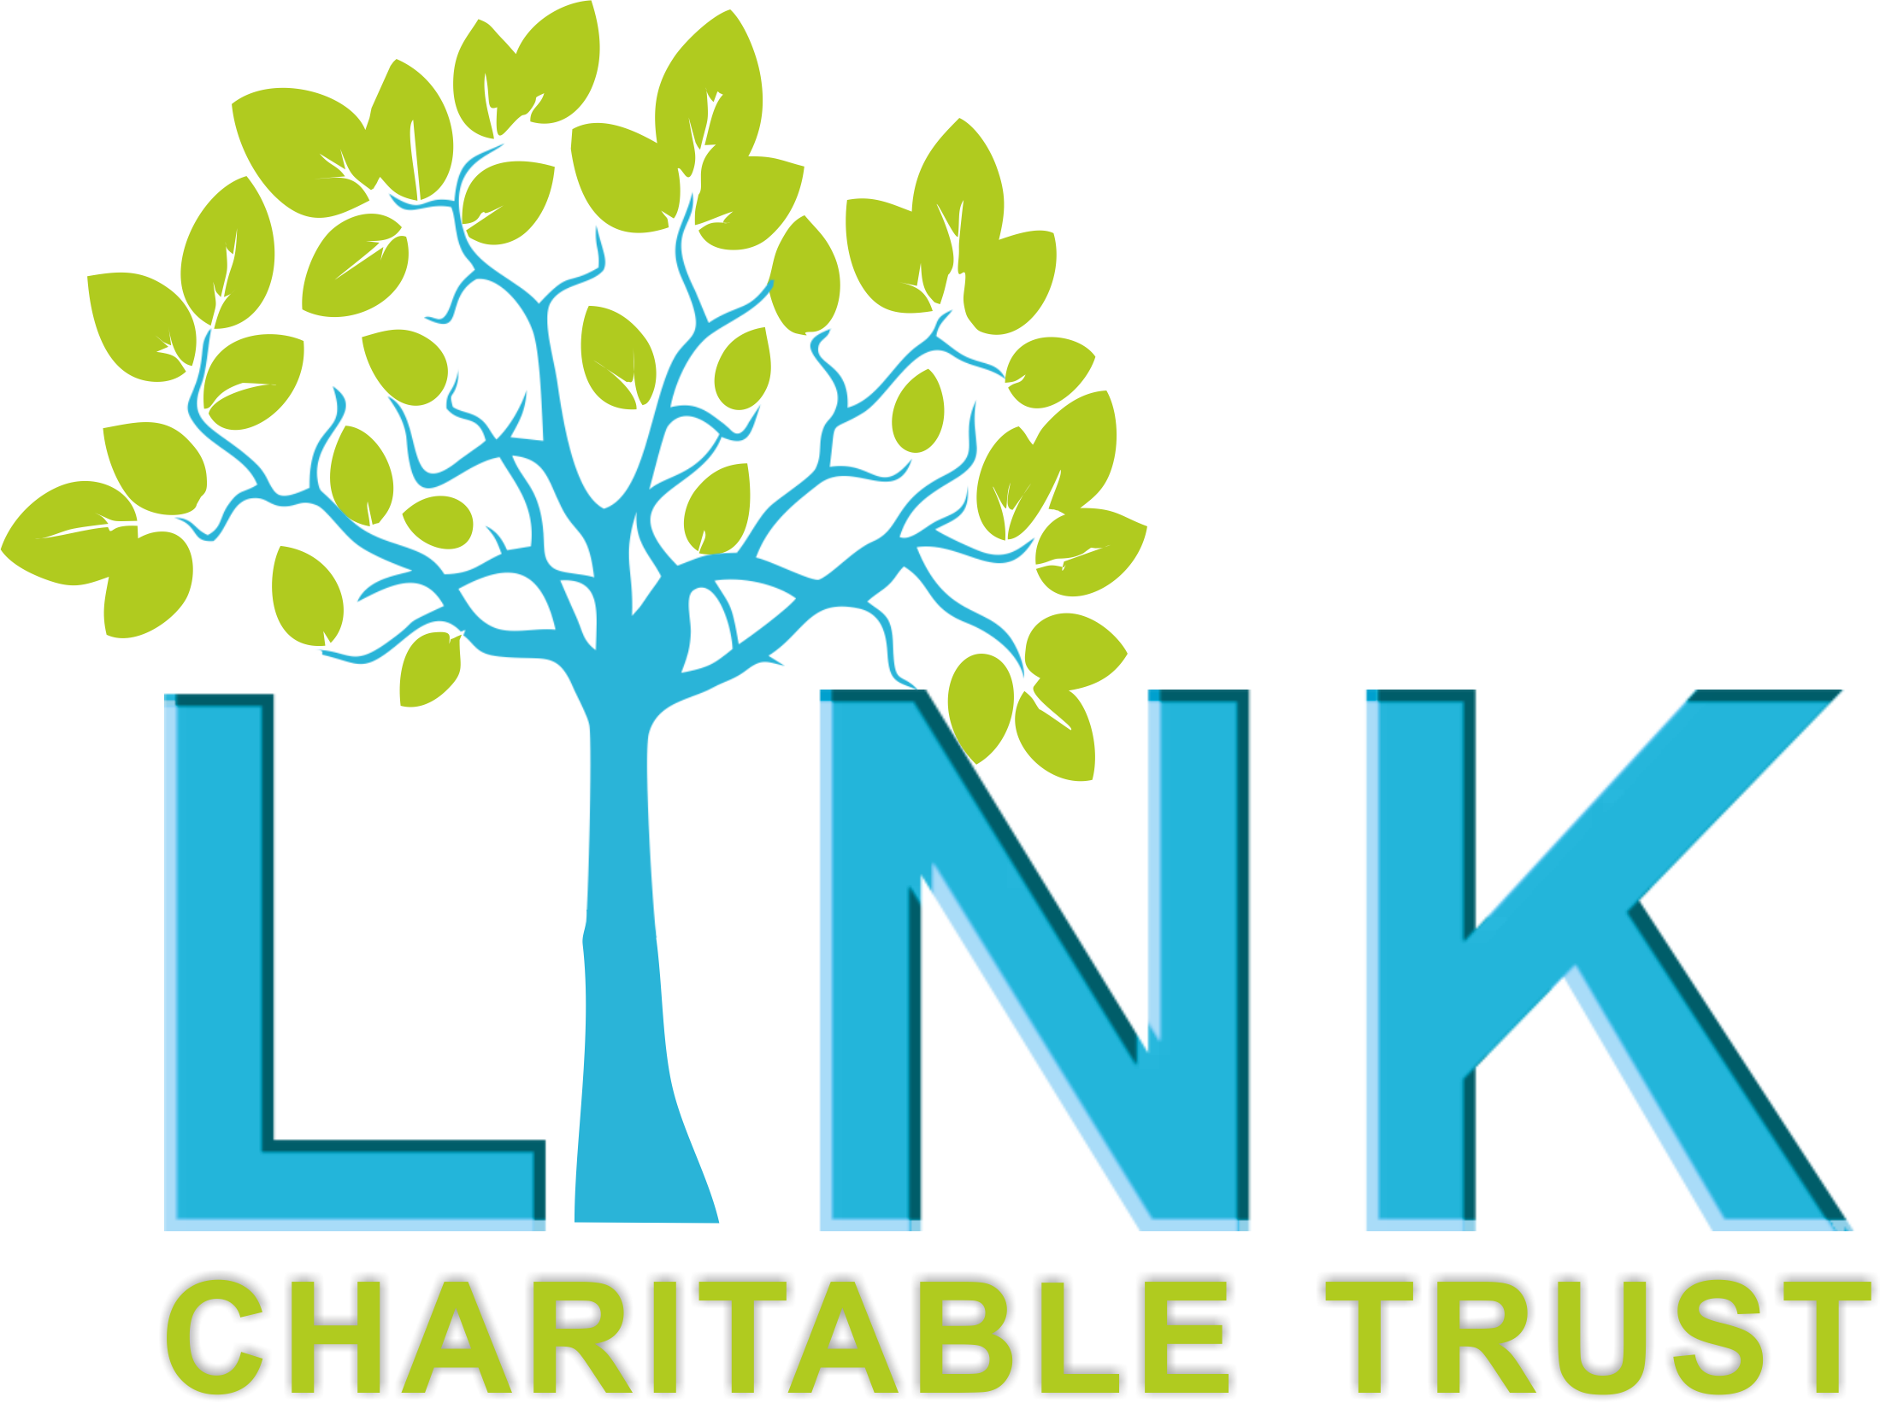

**THE LINK CHARITABLE TRUST**

**JOB DESCRIPTION**

**Title:** Children and Young People’s Project Worker

**Location:** Redcar and Cleveland

**Employment Terms:** 22.5 hours per week (fixed term to 1st March 2026)

**Service Area:** Children, Young People and Families

**Reporting to:** CYP Project Coordinator

**Accountable to:** Chief Executive Officer

**Salary:** £12.76

----------------------------------------------------------------------------------------------------------------

The Link Charitable Trust (LCT) is a Redcar based charity supporting Children, Young People, Adults and Families through a range of services aimed at improving wellbeing and to promote positive Mental Health.

**Job Purpose**

The CYP Project Worker will work within the Link Charitable Trust (LCT) and will be involved in the development of the Children and Young People’s Service to improve Emotional Wellbeing and to empower Children and Young people to reach their potential.

You will provide a range of support depending on the needs of the children and young people including both 1:1 outreach and group activities, and working closely with families to ensure a whole family approach, working alongside the LCT Adult services.

1:1 Outreach will include building positive relationships, and supporting children and young people both practically and emotionally to achieve positive outcomes, build resilience, and be more integrated into the community and surrounding support systems, including supporting them into Link Charitable Trust activities.

Group activities will include a range of social and emotional activities designed to maintain positive wellbeing.

The successful candidate will have knowledge and experience of working with children and young people ages 0-14 with a range of complex needs in a variety of settings. The successful candidate must be empathetic, non judgemental and have the ability to work autonomously.

We desire someone committed to making a difference, who can bring enthusiasm and innovation to our organisation.

This post is fixed term until March 2026.

**Main responsibilities**

* To work with the team to come up with new and innovative ways of engaging young people in our services.
* To work directly with children and young people on a one to one basis providing low level practical and emotional support.
* To utilise community and local outdoor settings to provide support from.
* To facilitate group work, contributing to ideas for activities based on identified needs.
* To strive towards achieving positive outcomes, in a non-judgemental and empowering manner, also providing relevant and appropriate information and general support.
* To work with children and young people and families to identify, agree and achieve positive outcomes in line with service aims, objectives and quality standards.
* Working in collaboration to support children, and young people to build confidence in their own abilities.
* Advocate for and on behalf of children, young people and families referred to the service.
* Undertake all work in accordance with service policies and procedures.
* To work within the boundaries of service delivery and support to meet the requirements of the service needs.
* Liaise with other professionals working with the families in the project where appropriate.
* Ensure accurate data collection and statistics to inform project feedback.
* To make use of referral pathways following assessment for children, young people and families requiring other services, including statutory and voluntary agencies.
* To work within the I-Thrive framework, utilising local systems in place to ensure children and young people have access to the most appropriate support.
* To contribute to the further development of referral pathways.
* As far as possible, ensure children, young people and families are positively involved in making their own appropriate decisions (dependent upon age and understanding).
* Development and use of appropriate resources, to support children, young people and families.
* Receive supervision and case management monthly in relation to the overall project and personal development.
* Engage in and respond to personal development supervision to improve competencies and practice

**Monitoring, Evaluating and Developing Service Provision**

* Assist the line manager and colleagues in the monitoring, evaluation and development of the service with the tools and methodology provided for such.
* As appropriate, contribute to the development and learning of other service providers with regards to improving outcomes for children, young people and families within the service.
* Contribute to the setting of targets/action plans and work related to these, to assist service development.
* As appropriate, assist in the development and production of resources for the benefit of children, young people and families.
* Support children, young people and families to be involved as much as appropriate (according to age and understanding), with regards to involvement in the monitoring, evaluation and development of the service.

**Administration and Finance**

* Contribute to the day to day administration and running of the project, including appropriate keeping of all records relating to the users of the service, administration and finance, security and confidentiality of information/communication.
* Share appropriate information with children, young people and families, staff and volunteers and other agencies in accordance with the rules of confidentiality and protection of data.

**Work with Other Staff/Agencies**

* To create and maintain effective working relationships with external agencies.
* To liaise effectively with other local providers, on behalf of the service user
* Present the users of our service and the service overall in a positive and professional manner, not bringing the service into disrepute.
* As appropriate, represent the service and provide a positive service perspective at relevant inter-agency meetings (or other forms of joint working or training).
* Liaise with other staff and agencies to further meet the needs of service users in accordance with the service criteria, policies and procedures.
* Take part in the delivery of training (as appropriate), consultation with and guidance to others, pertaining to the level of development.

**A Professional and Ethical Service**

* To promote the safety of children, young people and families to further the aim of preventing abuse or the risk of abuse.
* To maintain appropriate notes and records on The LCT’S internal systems and in line with company Policies and Procedures.
* To undertake relevant Continuing Professional Development as required for the purposes of continued professional accreditation or registration and as identified through The LCT’s professional development and Appraisal system.
* To undertake line management supervision and case management as per The LCT’s supervision policy.
* To work within The LCT’s GDPR and Information Governance policies and procedures.
* To ensure a safe and secure working environment for self and others and to take action as necessary within Health and Safety and other guidelines.
* To adhere to all company Policies, Procedures and Guidelines.
* To promote and value the rights, responsibilities and diversity of people using the service.
* Promote and act in accordance with the service action plans with regards to equal opportunity and non-discrimination.
* Undertake training, supervision and appraisal to provide a high standard of service in a learning, innovative and continuous personal development environment.
* To act in a professional manner at all times whilst representing the service.
* Undertake other duties and responsibilities as required from time to time, commensurate with the post.

This job description is designed to identify principal responsibilities only. The post holder is required to be flexible in developing the role in accordance with changes in The Link Charitable Trusts organisational objectives and priorities.