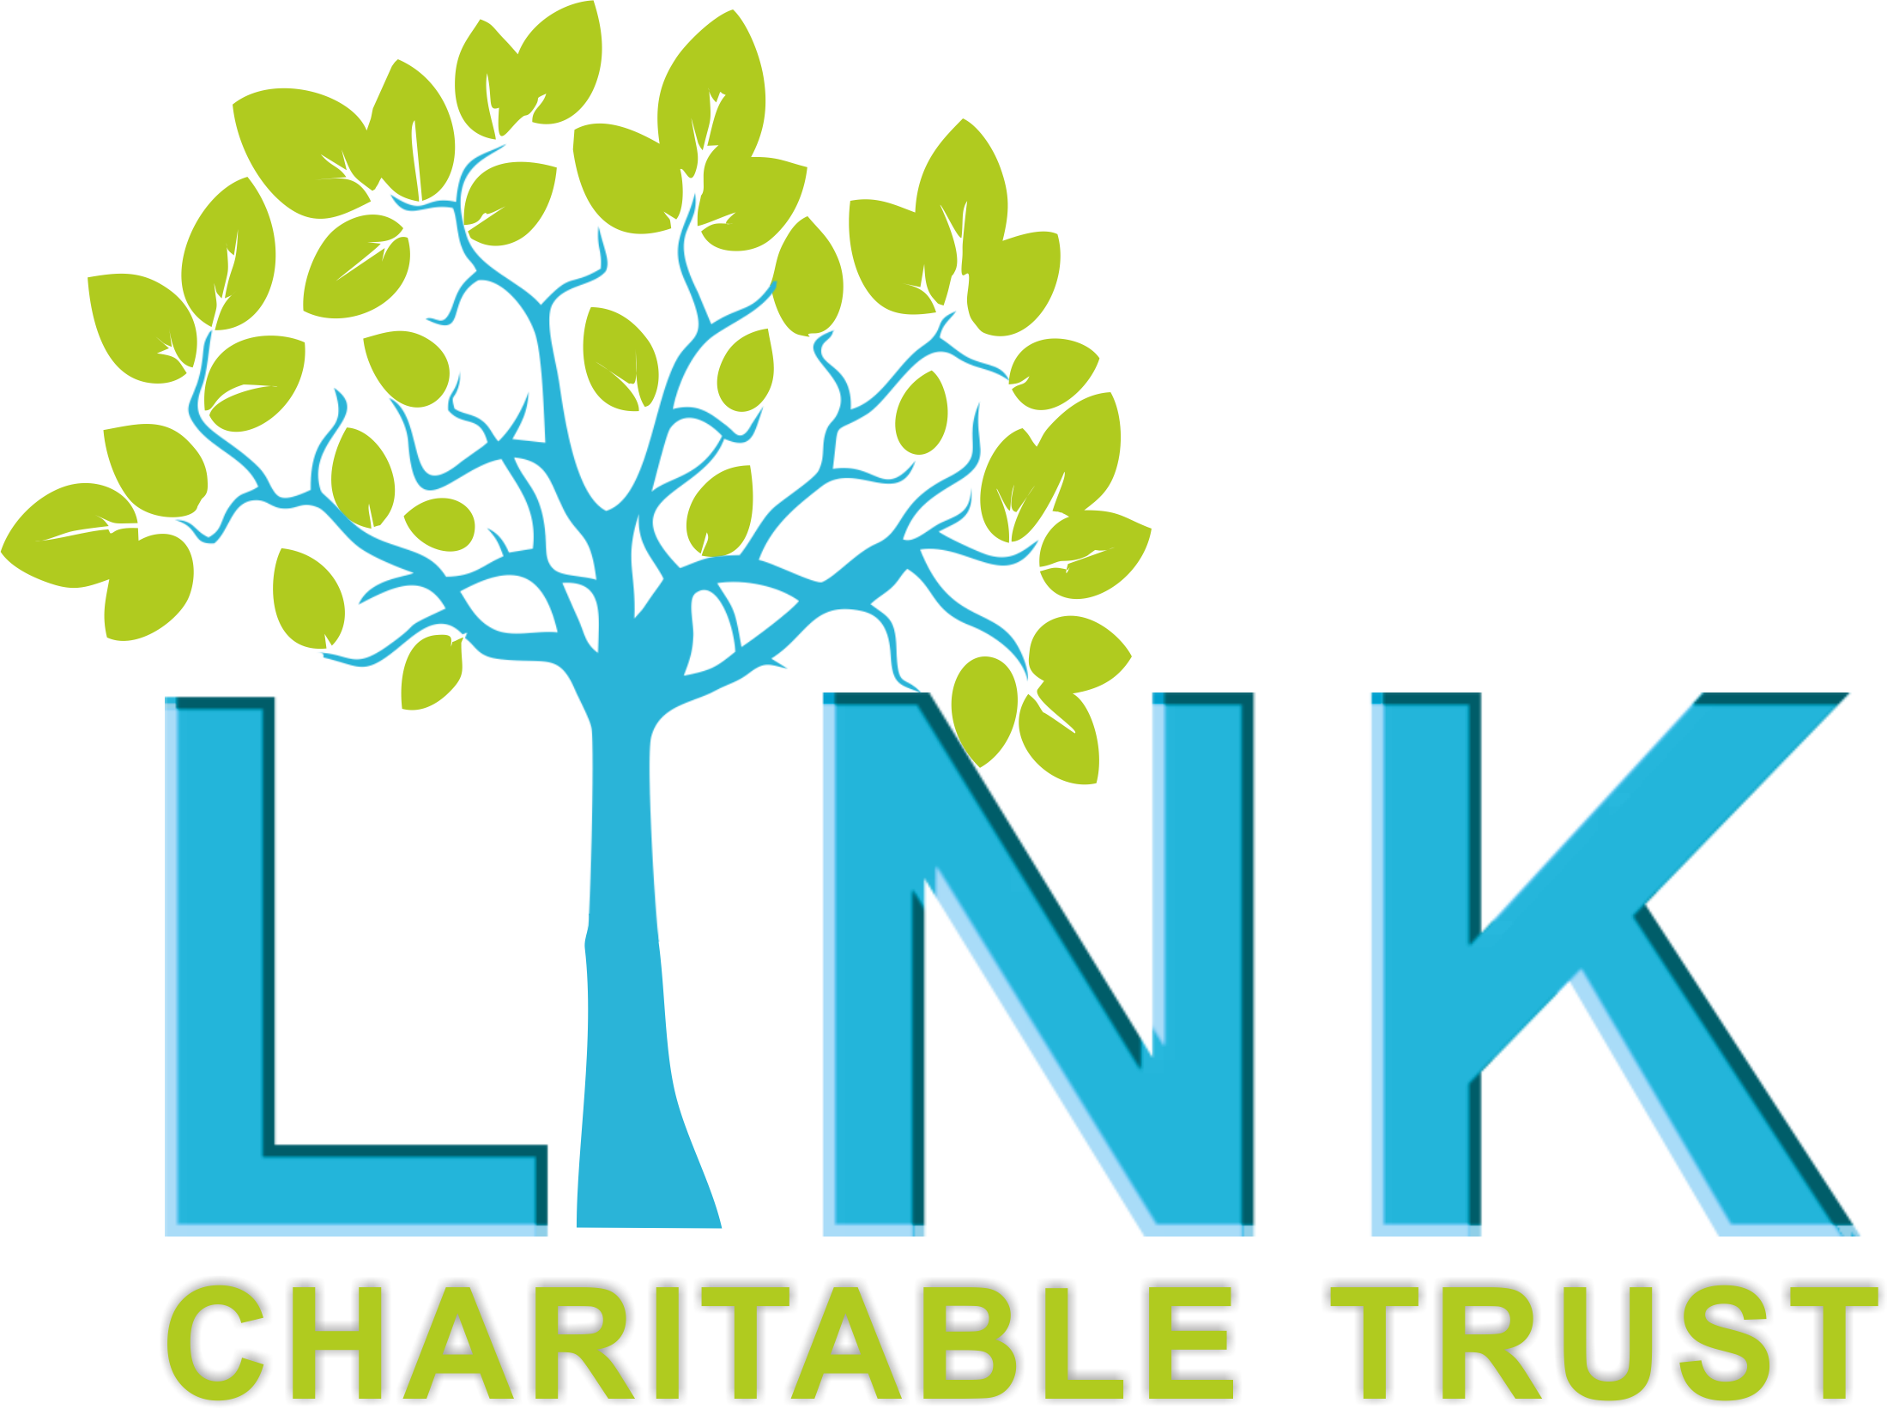

**THE LINK CHARITABLE TRUST**

**JOB ADVERTISEMENT**

**Children and Young People Project Worker**

The Link Charitable Trust (LCT) is a Redcar based charity working with children, young people, families and vulnerable adults. We support individuals to make positive changes to their lives through a range of emotional, social and wellbeing activities and services within the community.

We are currently recruiting 1 x Children and Young People Project Worker to join our organisation. This post is fixed term until March 2026, 22.5 hours per week, £12.76 ph.

Hours may be negotiable, however there are some existing commitments we would like the postholder to honour which can be discussed at interview.

The role is to provide a range of support including both 1:1 outreach and group activities, and working closely with families to ensure a whole family approach, working alongside the LCT Adult services.

The post-holder will work within The Link Charitable Trust as part of a wider team.

**Application Deadline: Wednesday 12th February**

**Interviews: Thursday 20th February**

**To apply for this post, please complete an application form and send to** [**Callum@linkct.org.uk**](mailto:Callum@linkct.org.uk)

**Application packs can be found on our website (**[**www.linkct.org.uk**](http://www.linkct.org.uk)**), or you can contact us by email:** [**office@linkct.org.uk**](mailto:office@linkct.org.uk) **or 01642 989198.**

For more information please contact Lorraine Bateman on 01642 989198