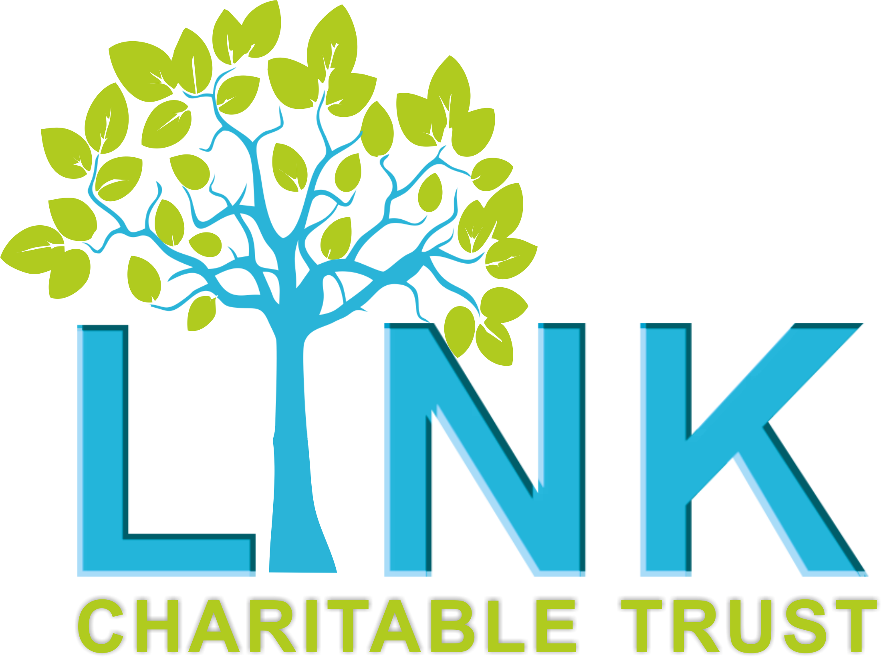

**THE LINK CHARITABLE TRUST**

**JOB ADVERTISEMENT**

**Mental Health Outreach Worker**

The Link Charitable Trust (LCT) is a Redcar based charity working with children, young people, families and vulnerable adults. We support individuals to make positive changes to their lives through a range of emotional, social and wellbeing activities and services within the community.

We are currently recruiting 1 x MH Outreach Worker to start within our organisation. This post is fixed term until 31st July 2027, 22.5 hours per week, £12.76 ph.

Working hours and patterns are negotiable.

The post-holder will work within The Link Charitable Trust as part of a wider team. The role will encompass supporting people with their Mental Health and Wellbeing within our venue and the wider community across Redcar and Cleveland in relation to the goals they would like to set to promote their social recovery and needs.

**Application Deadline: 20th January 2025**

**Interviews: 28th January 2025**

**To apply for this post, please complete an application form and send to** [**Callum@linkct.org.uk**](mailto:Callum@linkct.org.uk)

**Application packs can be found on our website (**[**www.linkct.org.uk**](http://www.linkct.org.uk)**), or you can contact us by email:** [**office@linkct.org.uk**](mailto:office@linkct.org.uk) **or 01642 989198.**

For more information please contact Katie Finkill on 01642 989198