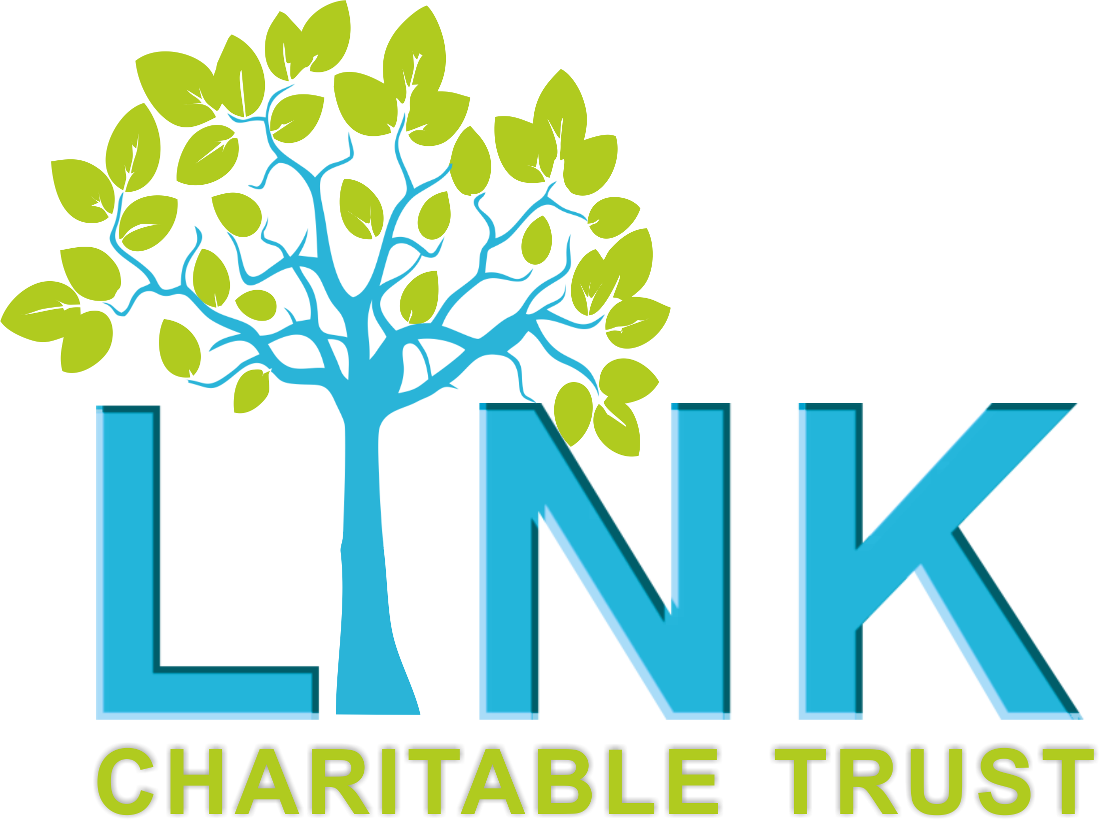

**The Link Charitable Trust**

**JOB DESCRIPTION**

**Title:** Mental Health Outreach Worker

**Location:** Redcar and Cleveland

**Employment Terms:** 22.5 hours per week. Fixed term until July 2027

**Service Area:** Adult Mental Health

**Reporting to:** Adult Mental Health Project Coordinator

**Accountable to:** Chief Executive Officer

**Salary:** £12.76 per hour

----------------------------------------------------------------------------------------------------------------

The Link Charitable Trust (LCT) is a Redcar based charity working with locally based children, young people and families, by offering regular drop-in advice and information sessions, educational training programmes and a range of activity and social groups for children, young people, parents/carers and adults to reduce social isolation and increase their emotional wellbeing and mental health.

As a result of the Coronavirus Pandemic we saw an increase in mental health difficulties of the parents, carers and other adults we work with. We provide specific mental health support for adults in the Redcar and east Cleveland Area.

**Job Purpose**

The post-holder will work within The Link Charitable Trust as part of a wider team. The role will encompass supporting people with their Mental Health and Wellbeing both within our venue and the wider community in relation to the goals they would like to set to improve their wellbeing.

The role will include the provision of one to one Emotional Wellbeing support and a range of both practical and wellbeing focussed work to develop skills which will assist people to lead healthy lives and look after their mental well-being. The role will fully involve individuals in their own recovery, supporting them to identify their own needs. The role will also include supporting people into other organisations where required or when we are unable to meet their needs.

**Main Duties and Responsibilities**

* Facilitate improvement of people’s mental and emotional wellbeing through one to one support, implementing coping skills and strategies.
* Support the delivery of group activities, where appropriate developing and leading on new groups, and supporting existing wellbeing groups across all Adult Services.
* Provide needs assessments which gather an understanding of people’s needs, in a compassionate and empathetic manner, and assess risk.
* Providing goal based support, with regular reviews and clear action plans in place.
* Use the Warwick Edinburgh Mental Wellbeing Scale to ensure support is effective.
* To strive towards achieving positive outcomes, in a non-judgemental and empowering manner, also providing relevant and appropriate information and general support.
* Provide early intervention that can prevent the escalation of need
* Improve access to secondary services for those with more complex needs.
* Reduce the stigma attached to accessing mental health support through normalising and providing a non-clinical support setting, and language around mental health issues that is accessible and has an informal feel.
* Build relationships with adults who are sometimes reluctant to attend mental health services, who are seen as ‘hard to reach’ and offer support to those who find it difficult to move into employment.
* Educate and involve family members and others in support where relevant or necessary.
* Attend multi-disciplinary meetings relating to referrals or clients service users where appropriate.
* Keep coherent and accurate records of all in line with service protocols
* Work closely with other members of the team ensuring appropriate step-up and step-down arrangements are in place to maintain a stepped care approach.
* Ensure the appropriate use of routine outcome monitoring tools, and support the Project Coordinator in working towards grant requirements.
* To make use of referral pathways following assessment of parents, carers, adults requiring other services, including statutory and voluntary agencies.
* To operate within the Service Referral to Discharge Protocols.
* Through close case management and supervision, escalate cases where the level of need becomes beyond scope, or more severe, ensuring adherence to other relevant elements of service delivery.
* Adhere to an agreed activity contract relating to the overall number of contacts
* To attend supervision meetings prepared, adhering to agreed action plans.
* Develop the service into wider areas including East Cleveland, Grangetown and South Bank. This will include scoping out new areas to provide support from and appropriate meeting places to reduce geographical barriers to accessing support.
* To manage your own case load, achieving a balance between offering support for as long as needed, and managing demand/waiting lists
* To meet regularly with your line manager to discuss caseload, planning, and ensure continuous professional development.

**Partnership Working**

* To create and maintain effective working relationships with other professionals, providing advice and consultative support on emotional and mental health issues, and in relation to appropriate referral pathways for clients experiencing a range of mental health difficulties.
* To liaise effectively with other local providers, including statutory, voluntary sector organisation and third sector organisations on behalf of the client.
* To build effective working relationships with other local mental health, and connect with a range of local agencies to have a comprehensive knowledge of what is available.
* Link together and supporting partnership working with other organisations to improve access to services for the community
* Be available to attend some networking events in collaboration with The Marketing Coordinator to both promote our services and reach out to others.

**Safeguarding**

* Responsible for safeguarding clients at all times and operating within local policies and procedures.
* Under guidance and support taking appropriate safeguarding action to protect clients at risk of significant harm.
* To share appropriate information, keeping within the boundaries of Confidentiality and Information Sharing protocols.

**A Professional and Ethical Service**

* To maintain appropriate notes and records on the LCT’S database and in line with The Link Charitable Trusts Policies and Procedures.
* To undertake relevant Continuing Professional Development as required for the purposes of continued professional accreditation or registration and as identified through The Link Charitable Trusts professional development and Appraisal system.
* To work within The Link Charitable Trusts GDPR and Information Governance policies and procedures.
* To ensure a safe and secure working environment for self and others and to take action as necessary within Health and Safety and other guidelines.
* To adhere to all The Link Charitable Trusts Policies, Procedures and Guidelines.
* To promote and value the rights, responsibilities and diversity of people using the service.

**Other**

* Mapping/updating of existing local services for signposting and review/update existing service
* Engage caseload to increase effective stakeholder participation in service design and delivery and increase attendance at participation events/groups.
* Regular promotion and marketing of mental health, prevention and early intervention linking in with local/national campaigns

This job description is designed to identify principal responsibilities only. The post holder is required to be flexible in development of the role in accordance with changes in The Link’s Charitable Trusts organisational objectives and priorities.